***A PROJECT REPORT ON***

**POWER QUALITY IMPROVEMENT IN DISTRIBUTED GENERATION WITH POWER STORAGE SYSTEM**

SUBMITTED IN PARTIAL FULFILMENT OF THE REQUIREMENTS

FOR THE AWARD OF THE DEGREE OF

**BACHELOR OF TECHNOLOGY**

**IN**

**ELECTRICAL AND ELECTRONICS ENGINEERING**

Submitted

By

S .VISWANADH (10F01A02A1)

B.SINDU (11F05A0202) N.SRAVANA SANDYA (10F01A0283)

SK.SUBHANI (10F01A02A7)

Under the esteemed guidance of

Mr. A.N.V.V. RAJA SEKHAR M.TECH 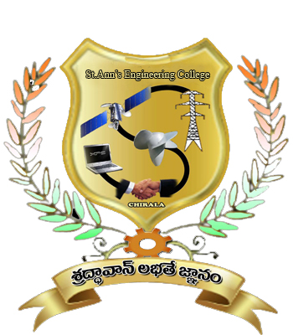

**DEPARTMENT OF ELECTRICAL AND ELECTRONICS ENGINEERING**

**ST.ANN’S COLLEGE OF ENGINEERING AND TECHNOLOGY**

(Accredited twice by **NBA**, **IE(I)Kolkata**,**& NAAC** With “**A”** GRADE approved by

AICTE, NEWDELHI & Permanently AFFLIATED TO JNTUK,KAKINADA)

**Nayunipalli, Vetapalem, Chirala-523187**

2010-2014

**ST.ANN’S COLLEGE OF ENGINEERING & TECHNOLOGY: CHIRALA- 523187**

**DEPARTMENT OF ELECTRICAL & ELECTRONICS ENGINEERING**

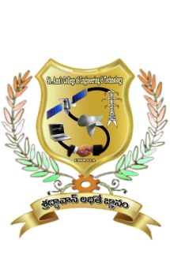

CERTIFICATE

This is to certify that the project entitled, “POWER QUALITY IMPROVEMENT IN DISTRIBUTED GENERATION WITH POWER STORAGE SYSTEM”, which is being submitted herewith for the award of B.Tech., is the result of the work completed by Mr/Ms……………………………………………………………………………., under my supervision and guidance within the four walls of the institute and the same has not been submitted elsewhere for the award of any degree.

(A.N.V.V.RAJA SEKHAR) (S.V.D. ANIL KUMAR)

Guide Head of department

External Examiner

**ACKNOWLEDGEMENT**

It is with immense pleasure that we would like to express our indebted gratitude to our guide **Mr. A. N.V.V.RAJA SEKHAR,** who has guided us a lot and encouraged us in every step of the project work. Her valuable moral support and guidance throughout the project helped us to a greater extent.

We feel elated to thank our Head of the Department **Mr. S.V.D** **ANIL KUMAR,** inspiring us all the way and arranging all the facilities and resources needed for our project.

We also thank **Mr. C. S. RAO**, principal of St. Ann’s College of Engineering & Technology, Chirala , for providing excellent environment in the college.

We express our sincere thanks to the teaching staff, Non-teaching staff for providing us the required impetus to complete this project.

Finally we wish to thank all our classmates and friends who directly or indirectly helped us to complete this project.

PROJECT ASSOCIATES

**S.VISWANADH (10F01A02A1)**

**B.SINDHU (11F05A0202)**

**N.SRAVANA SANDYA (10F01A0283)**

**SK.SUBHANI (10F01A02A7)**